ENGINEERING EXPLAINER INPUT
How Burj Khalifa Stands
A source-grounded guide to the buttressed-core system
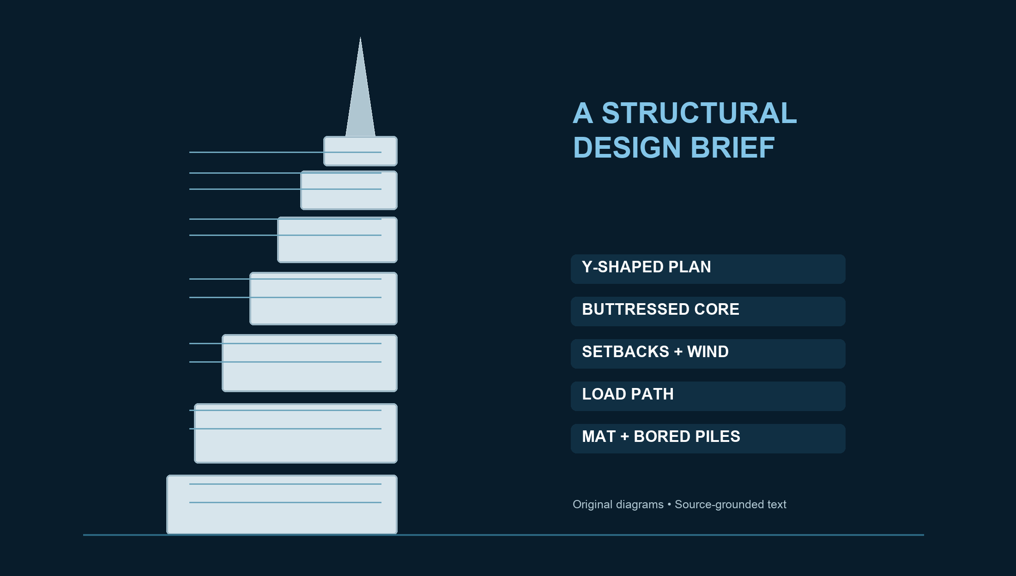
828 m • Dubai • Completed 2010
Educational synthesis — not construction documentation

1. The idea: three wings brace one core
KEY PRINCIPLE A Y-shaped plan turns three building wings into mutual buttresses around a six-sided central core.

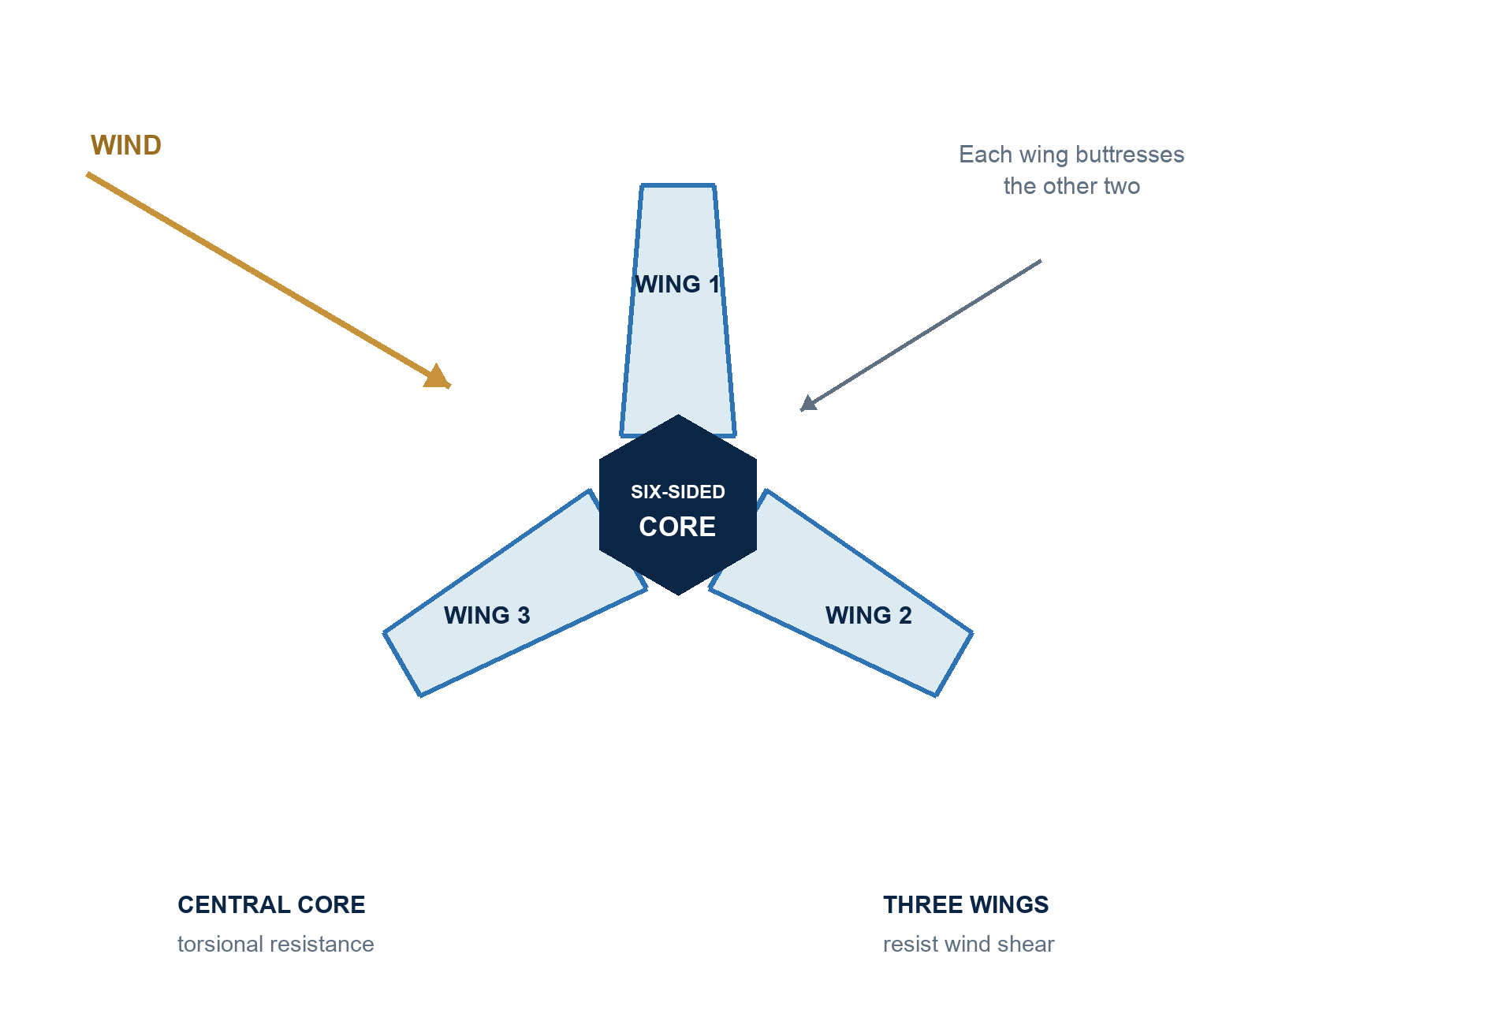
Figure 1. Simplified Y-shaped plan and buttressed-core action. Original diagram; not to scale.
The tower’s Y-shaped plan is both architectural and structural. Each wing has reinforced-concrete walls and perimeter columns. The three wings meet at a six-sided central core, so each wing helps brace the other two. The central core supplies torsional resistance, while the wings resist wind shear. [1][2]

Why the geometry matters
Because the wings and core are arranged as one integrated system, the tower gains stiffness without relying on a separate external frame. The plan also keeps repeated wall and column lines aligned, which supports a direct, buildable load path. [1]

2. The wind strategy: change the building before the wind can organize
WIND LOGIC The spiraling setbacks repeatedly change the tower’s width and orientation, disrupting coherent vortex formation.

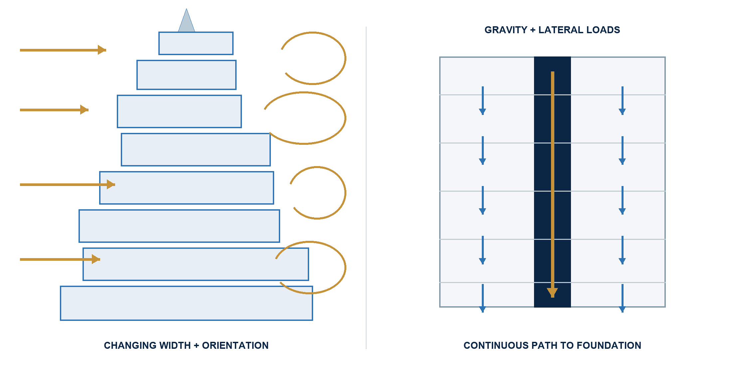
Figure 2. Wind disruption (left) and continuous load path (right). Original diagram.

Setbacks that ‘confuse the wind’
As the tower rises, each wing steps back in a spiraling sequence. Wind therefore encounters a different building shape at successive tiers. SOM describes the result as preventing wind vortices from coalescing around one consistent profile. [1]

A continuous path for forces
The setbacks are coordinated with the structural grid: columns above align with walls below. That alignment creates a smoother route for gravity and lateral forces and avoids unnecessary transfer structures at the steps. [1]

3. From tower to ground: mat and bored piles
FOUNDATION A 3.7 m reinforced-concrete mat spreads load into bored reinforced-concrete piles extending 43 m below the mat.

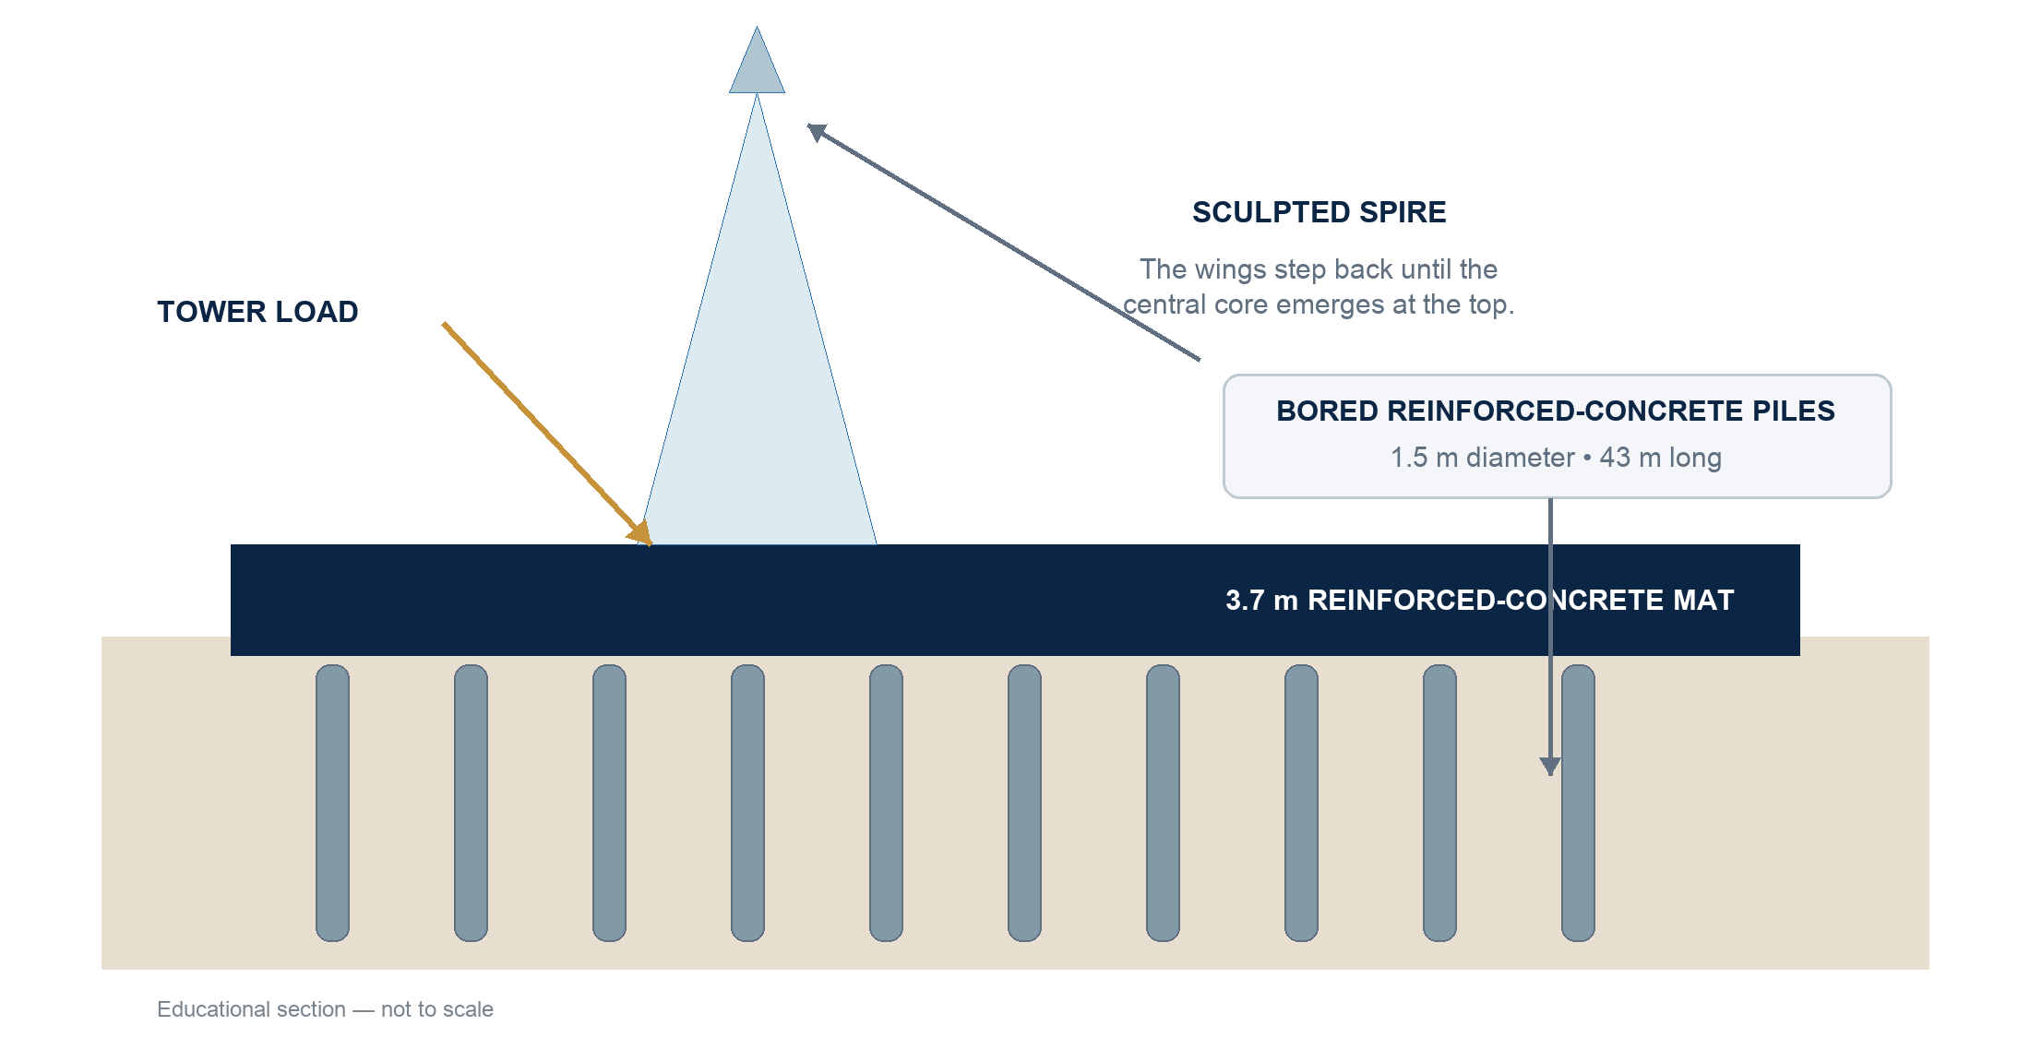
Figure 3. Simplified foundation section and upper-tower transition. Original diagram; not to scale.
The official project description states that the reinforced-concrete mat is 3.7 metres thick and was cast in four pours totaling 12,500 cubic metres of concrete. It is supported by bored reinforced-concrete piles, each 1.5 metres in diameter and 43 metres long. [2]

The top keeps the same logic
The three wings become narrower through successive setbacks. At the top, the central core emerges and culminates in a sculpted spire, preserving the tower’s tapering vertical expression. [1][3]

4. One-minute explainer blueprint
The first 20 seconds are intentionally self-contained so the same opening can be used as the Landing card preview.
Time | Visual | Narration / message
0–8 s | Full tower becomes a transparent structural silhouette. | At 828 metres, Burj Khalifa stands because its shape and structure were designed as one system.
8–14 s | Top view reveals three wings around a six-sided core. | Its Y-shaped plan forms a buttressed core: three wings brace a central hub.
14–20 s | Forces flow through wings and core toward the ground. | The core resists twisting; the wings resist wind shear and carry forces downward.
20–32 s | Successive tiers step back; wind lines break apart. | Each setback changes the tower’s width and orientation, keeping vortices from organizing around one profile.
32–43 s | Columns above align with walls below; arrows show a smooth path. | The structural grid keeps columns aligned over walls, creating a direct load path through the setbacks.
43–53 s | Cutaway reveals the mat and bored piles. | A 3.7-metre concrete mat spreads the load to bored piles extending 43 metres below.
53–60 s | Camera rises to the core emerging as a sculpted spire. | From foundation to spire, every transition preserves stiffness, continuity, and control of wind.
Table 1. Video structure for a 60-second English explainer; opening 20 seconds doubles as the silent card cut.

5. Source and visual-use notes
[1] SOM — Burj Khalifa project page: som.com/projects/burj-khalifa
[2] Burj Khalifa official — Structures: burjkhalifa.ae/the-tower/structures
[3] Burj Khalifa official — Architecture & Design: burjkhalifa.ae/the-tower/architecture-design
VISUAL RIGHTS All diagrams in this document were created for this educational demo. No third-party photography or copied blueprint is embedded.

Accuracy note: diagrams are explanatory abstractions and are not to scale. They should guide the video’s causal story, not be treated as construction drawings. Final generated frames should keep technical labels short and stable: Y-SHAPED PLAN, BUTTRESSED CORE, SETBACKS, WIND FLOW, LOAD PATH, MAT FOUNDATION, BORED PILES, SCULPTED SPIRE.

